TASK ON JENKINS-04 PART-1
Title:

- Setup Jenkins CICD pipeline using freestyle job using Docker containers using
- below code. https://github.com/betawins/hiring-app.git Stages:
- Git Clone
- SonarQube Integration
- Maven Compilation
- Nexus Artifactory
- Slack Notification
- Deploy On tomcat
Login back into jenkins
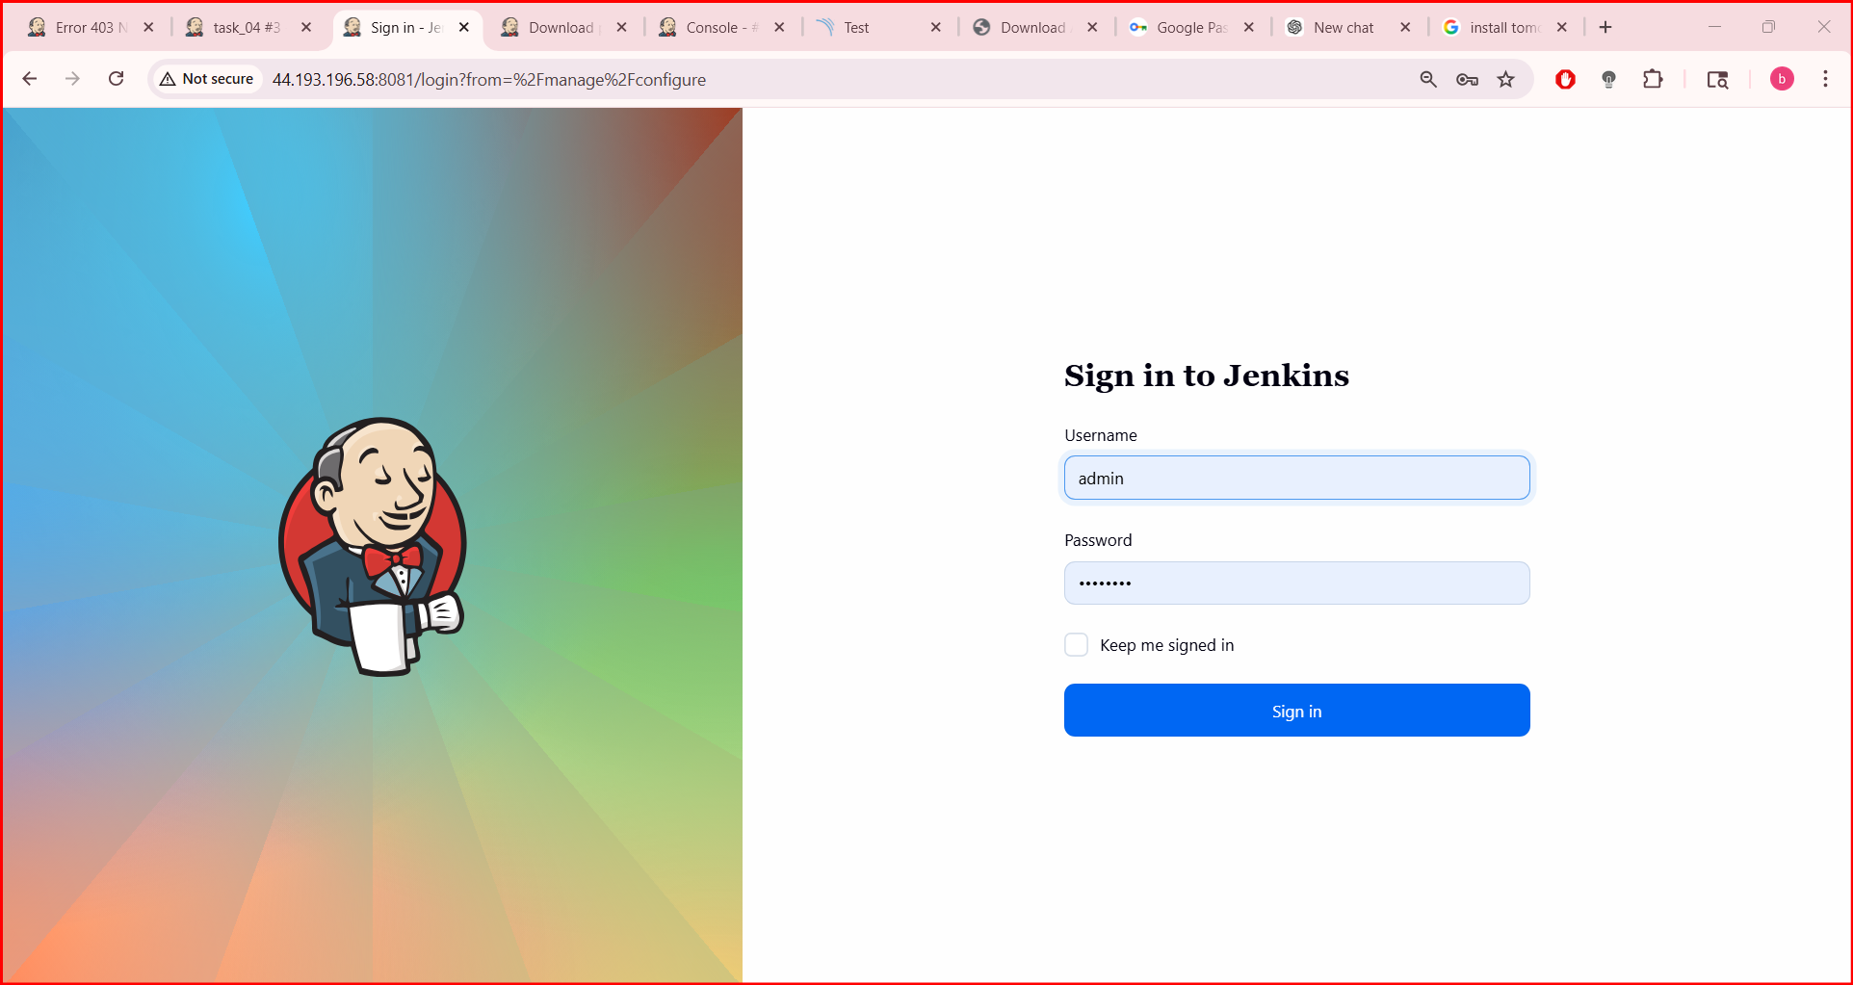
Run the sonarqube which already installed using docker in ec2
In the website the sonarqube page will be displayed

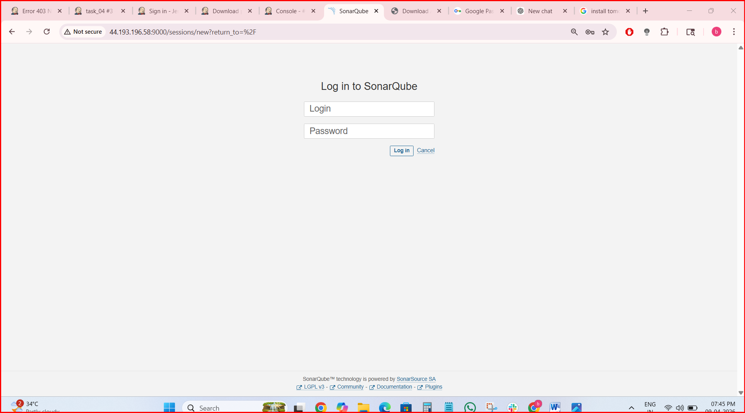
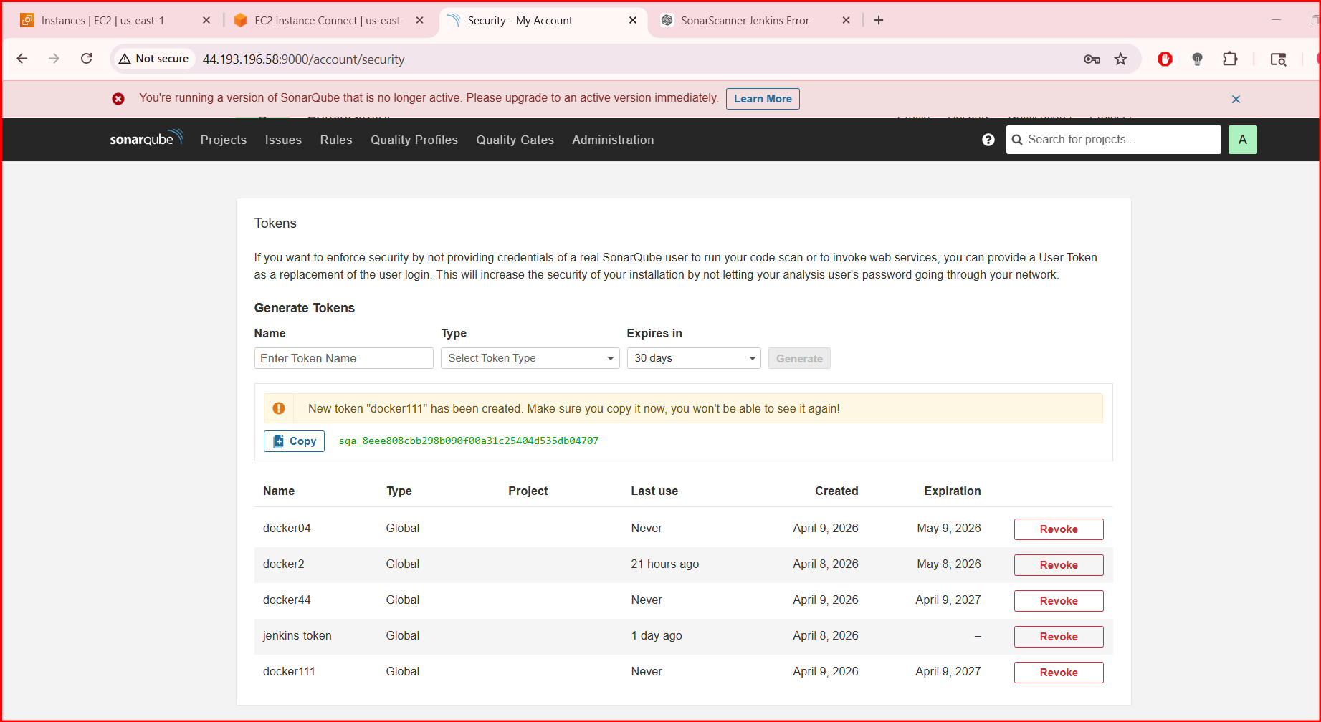
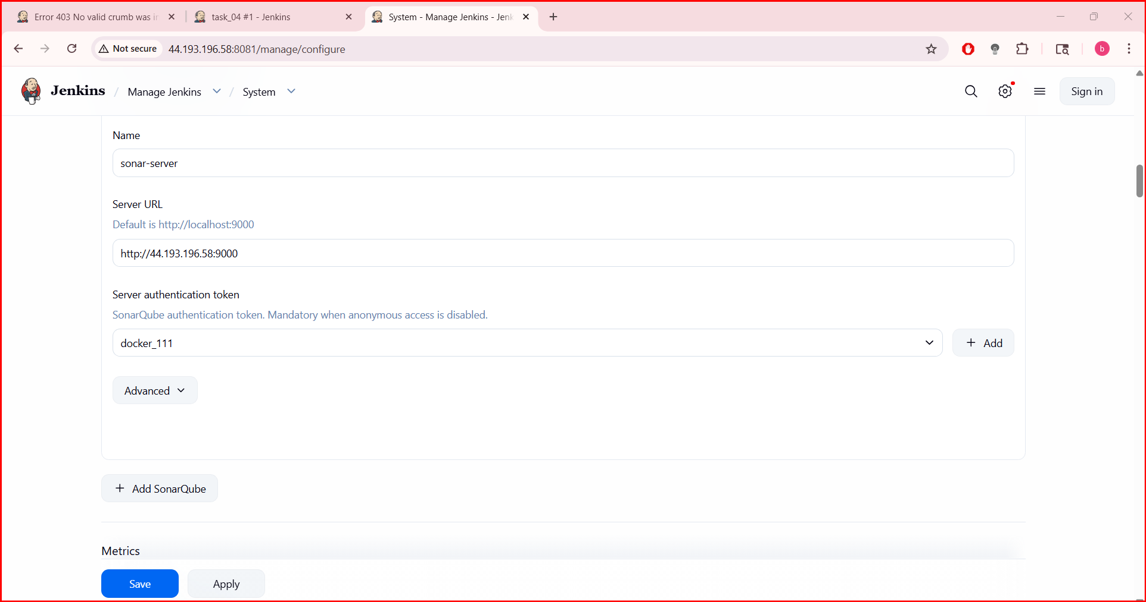
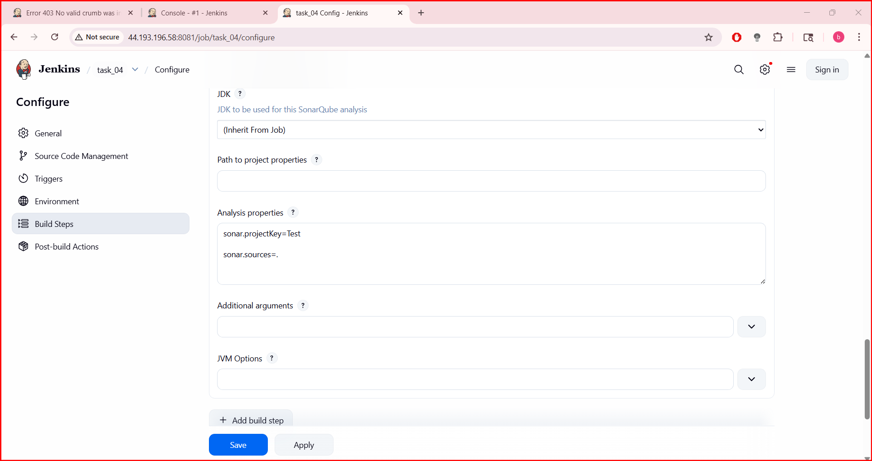
Sonarqube is ready and will check by clicking on build

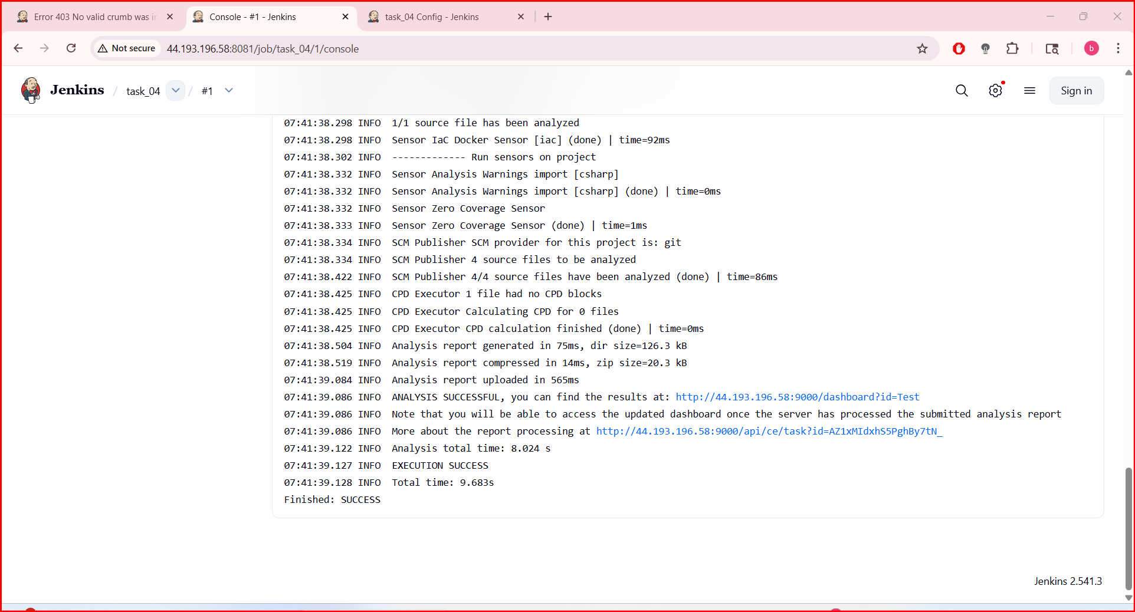
In Sonarqube Server also verified the BUILD

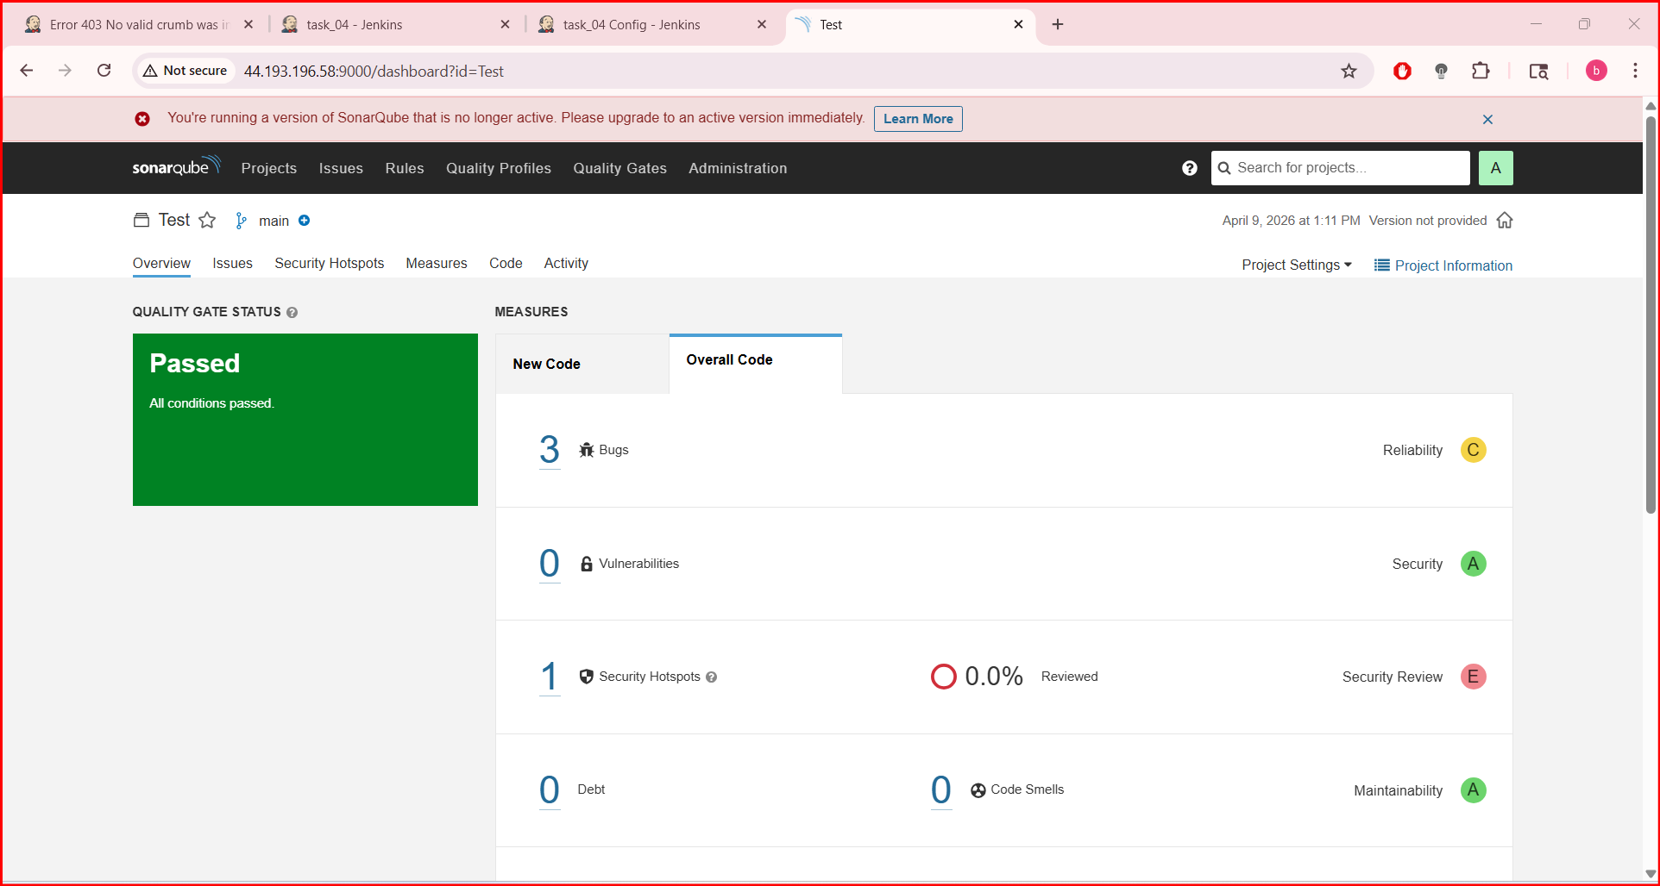
Maven Compilation
Visit official maven website and copy the tar.gz link and paste it over in ec2 in opt location

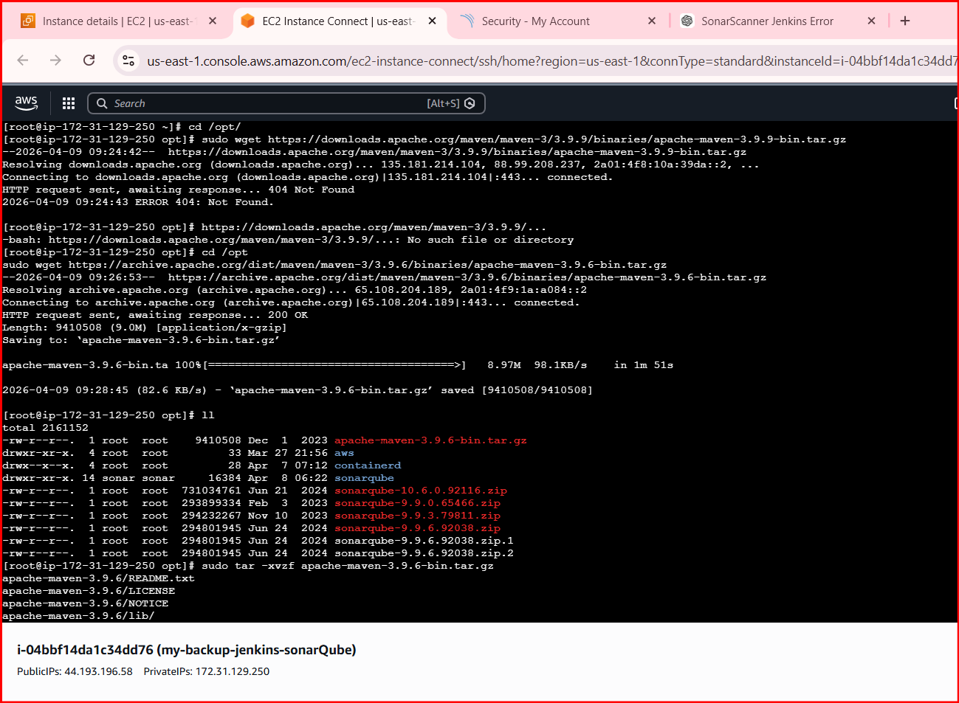
After getting the files use tar command to extract them

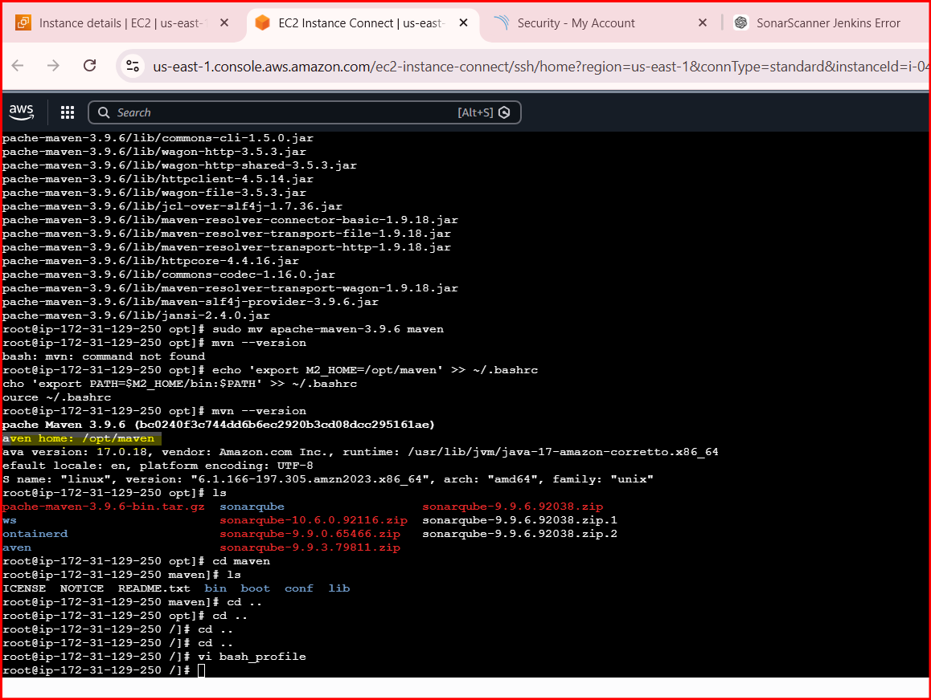
MAVEN HOME: /OPT/MAVEN
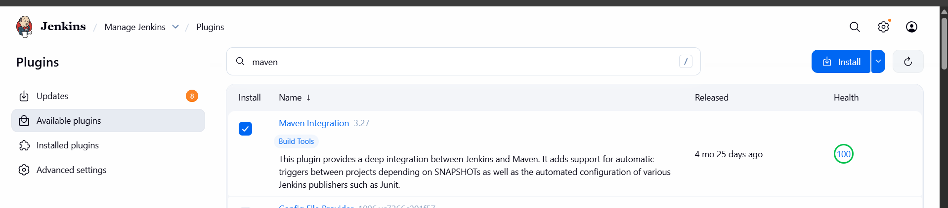
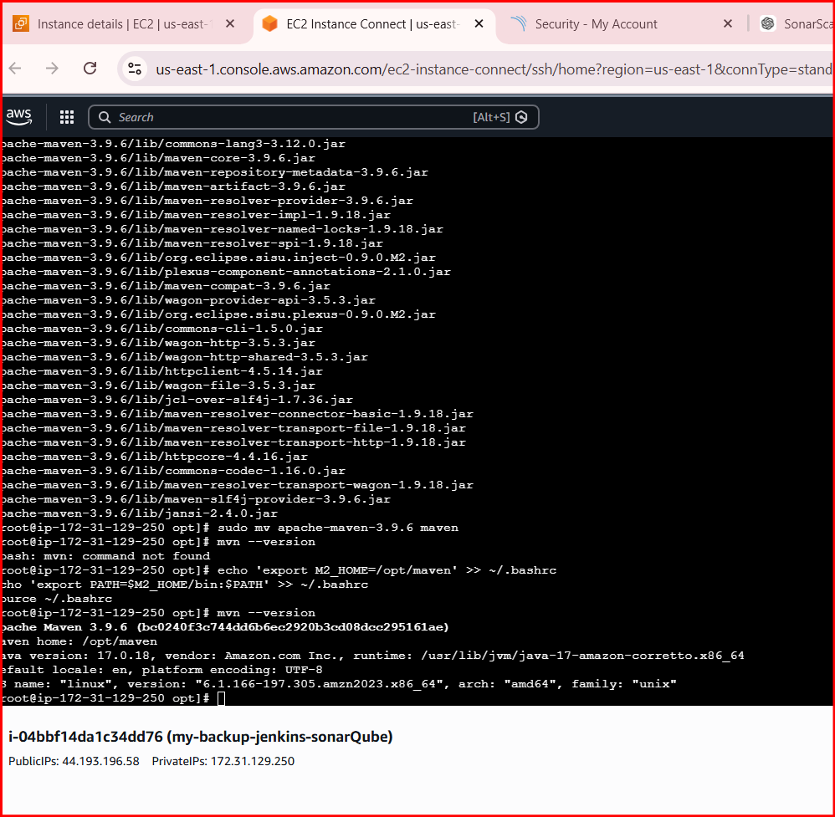
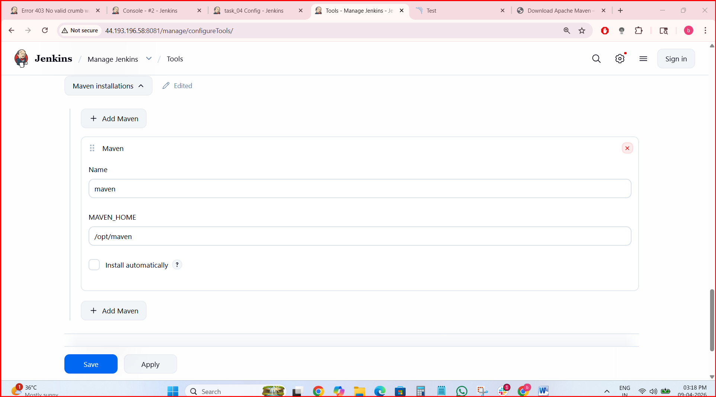
In job Configuration Select Invoke top level maven targets in BUILD Steps

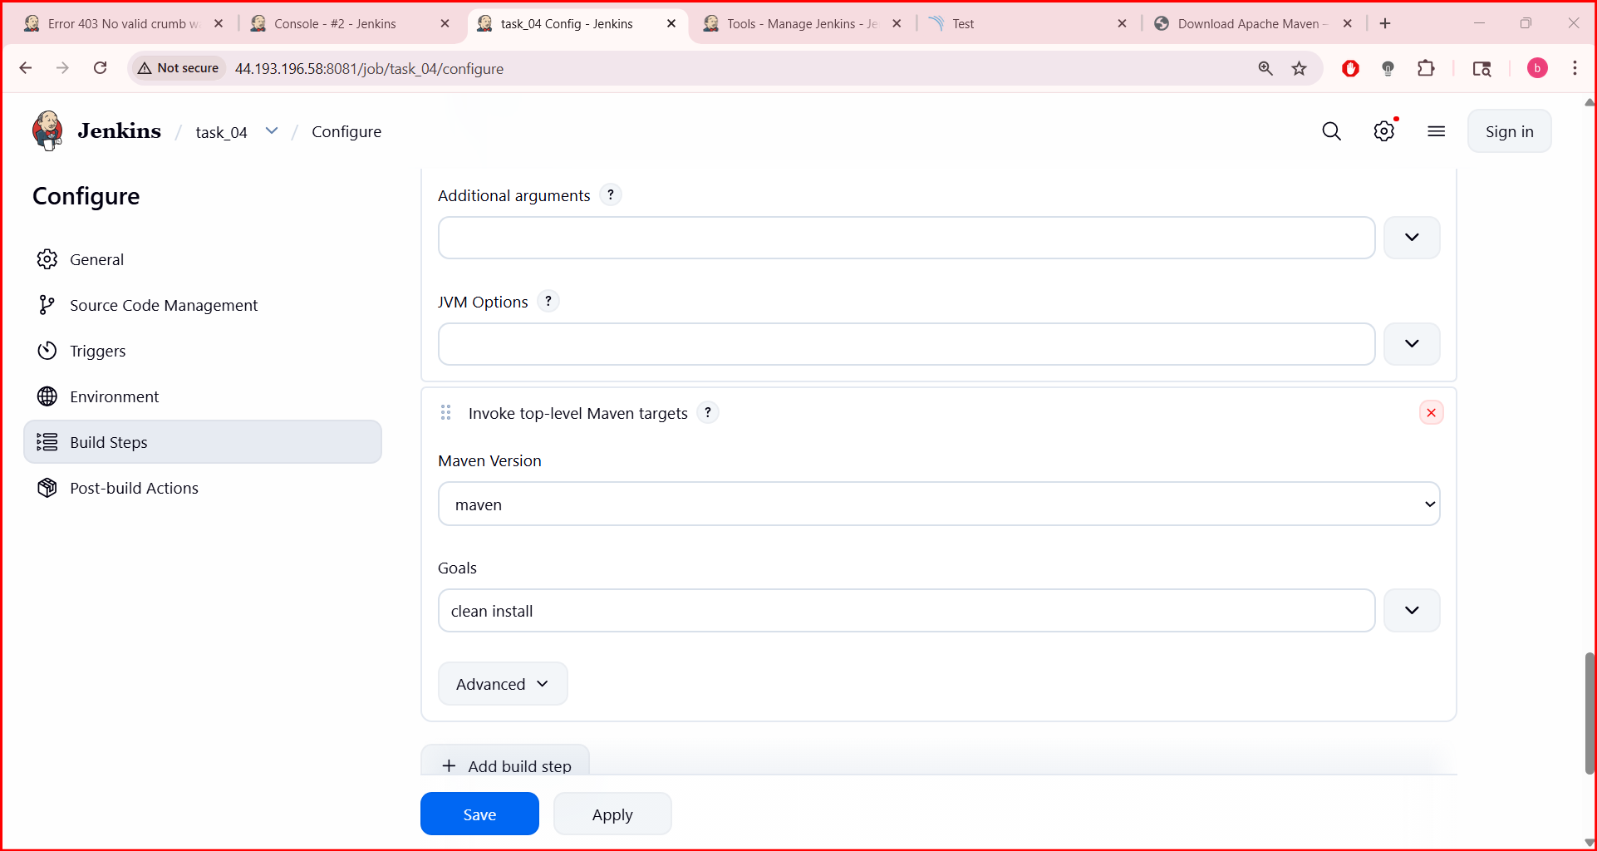
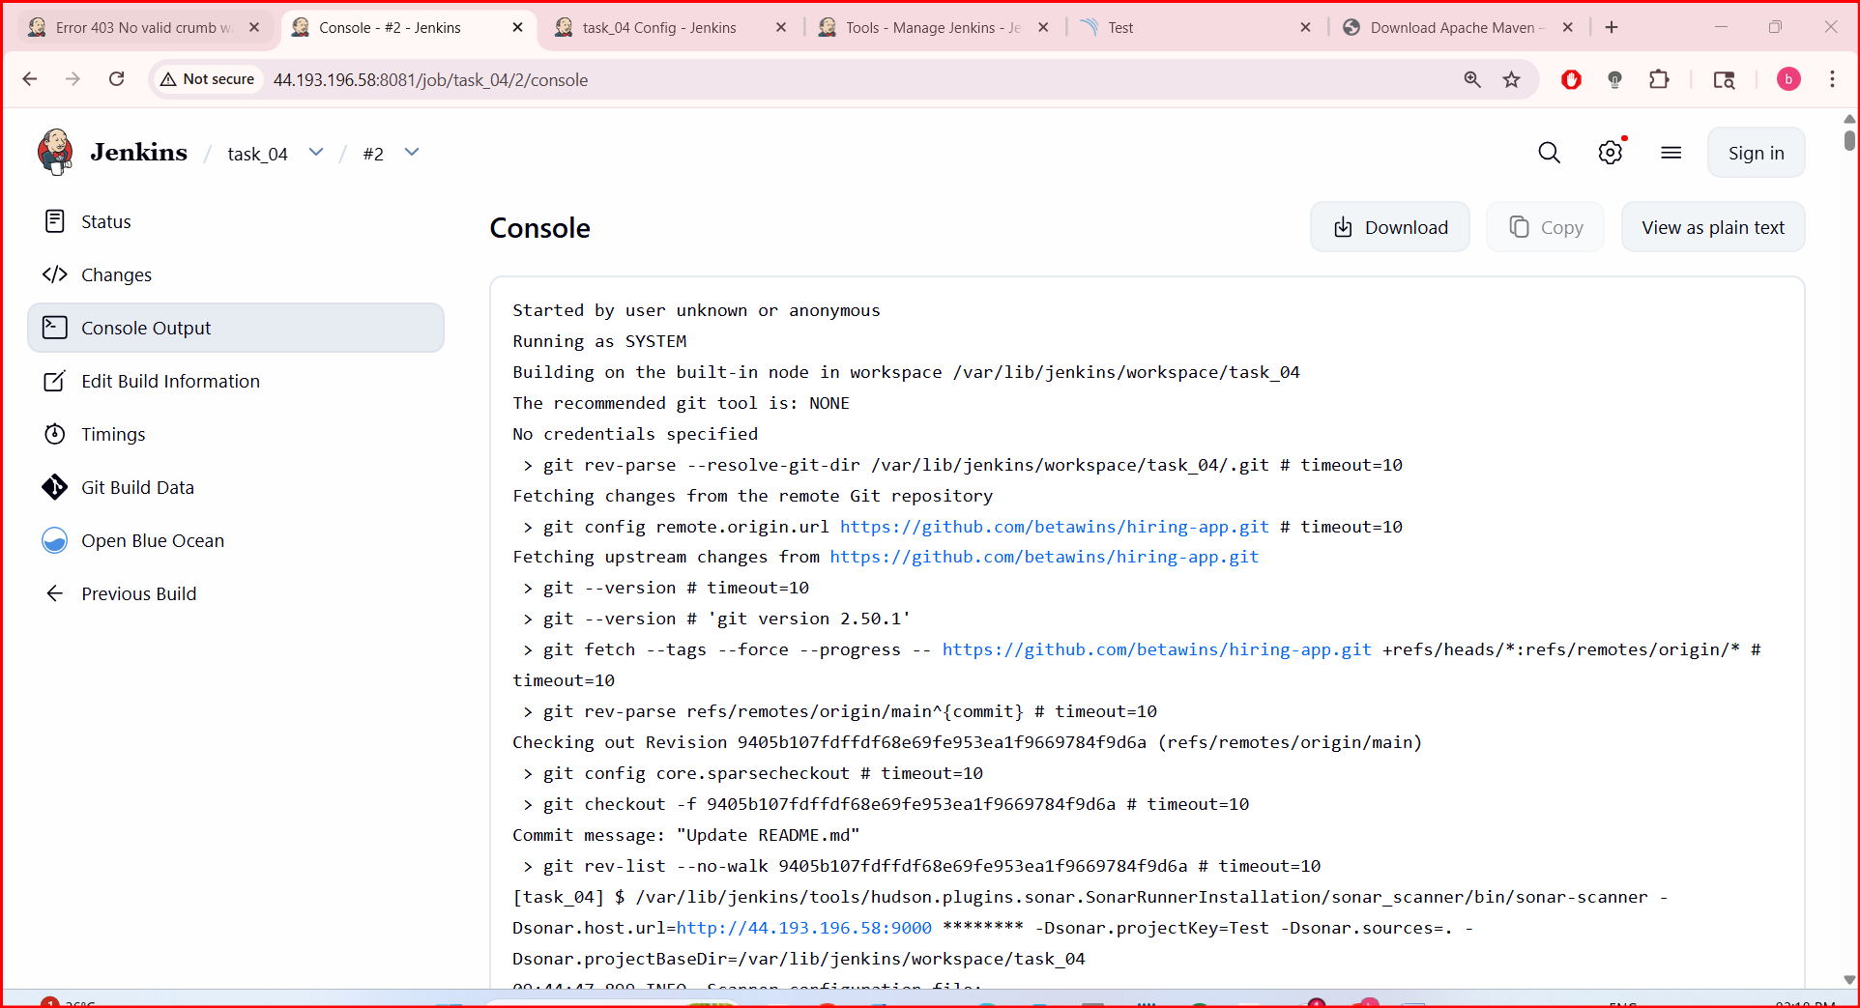
AFTER BUILD IS CONFIGURE AND OT STARTED BUILD PROCESS AND IT IS SHOWS SUCCESS
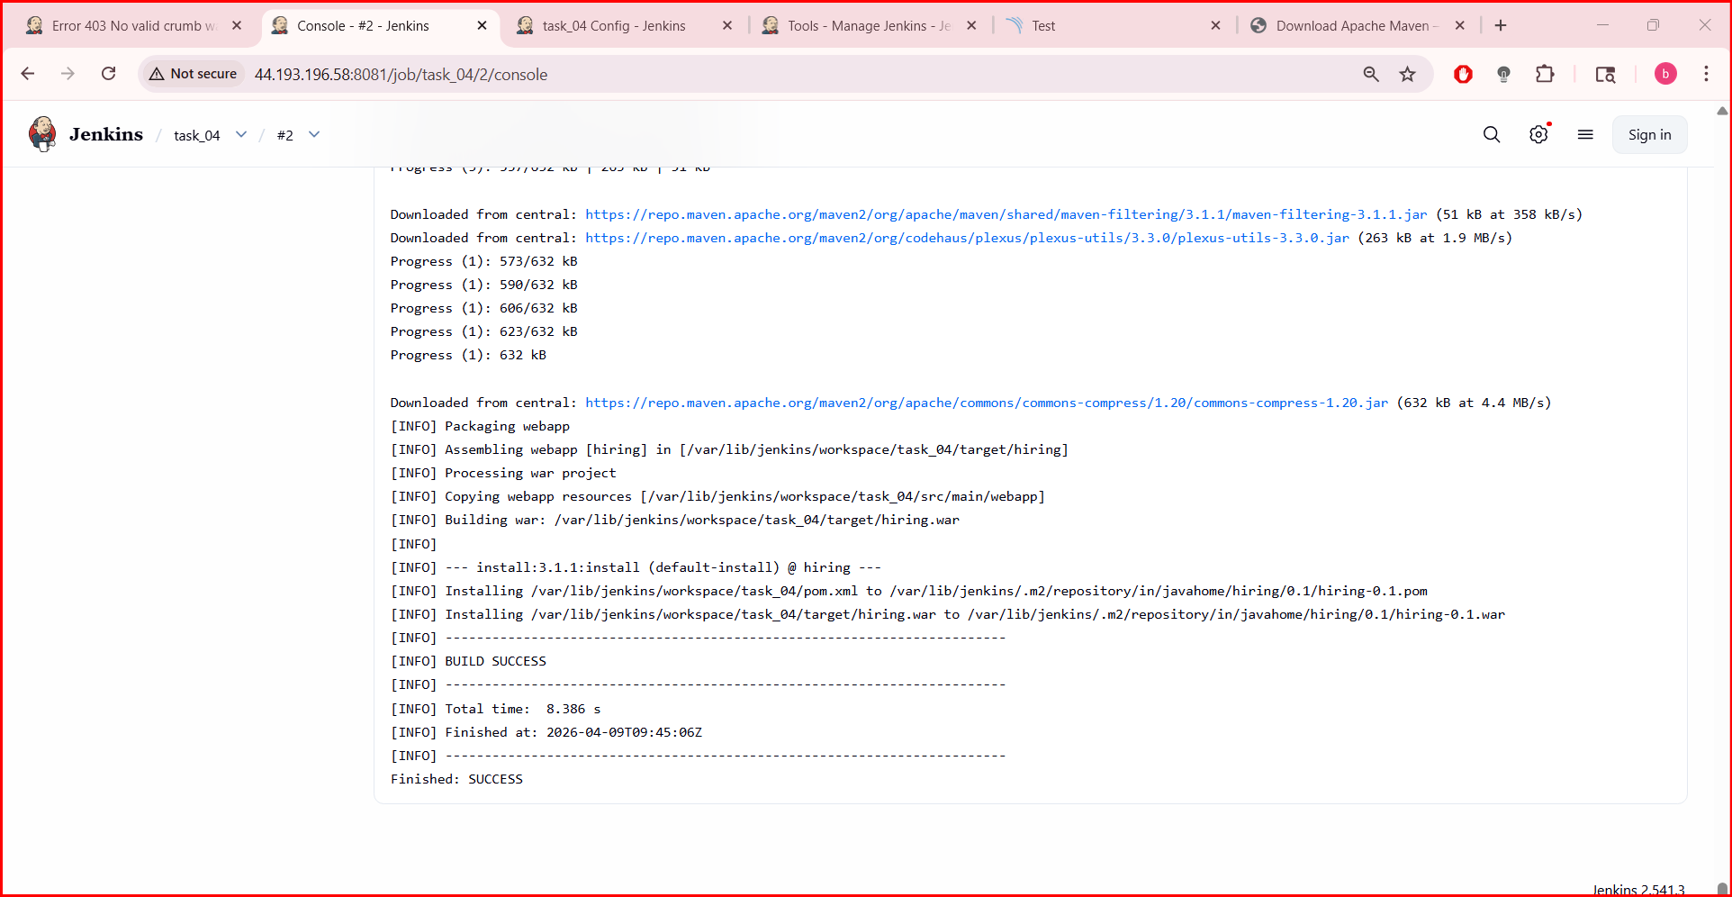
Nexus Artifactory
For nexus arti factory launch an instance and integrate with Jenkins
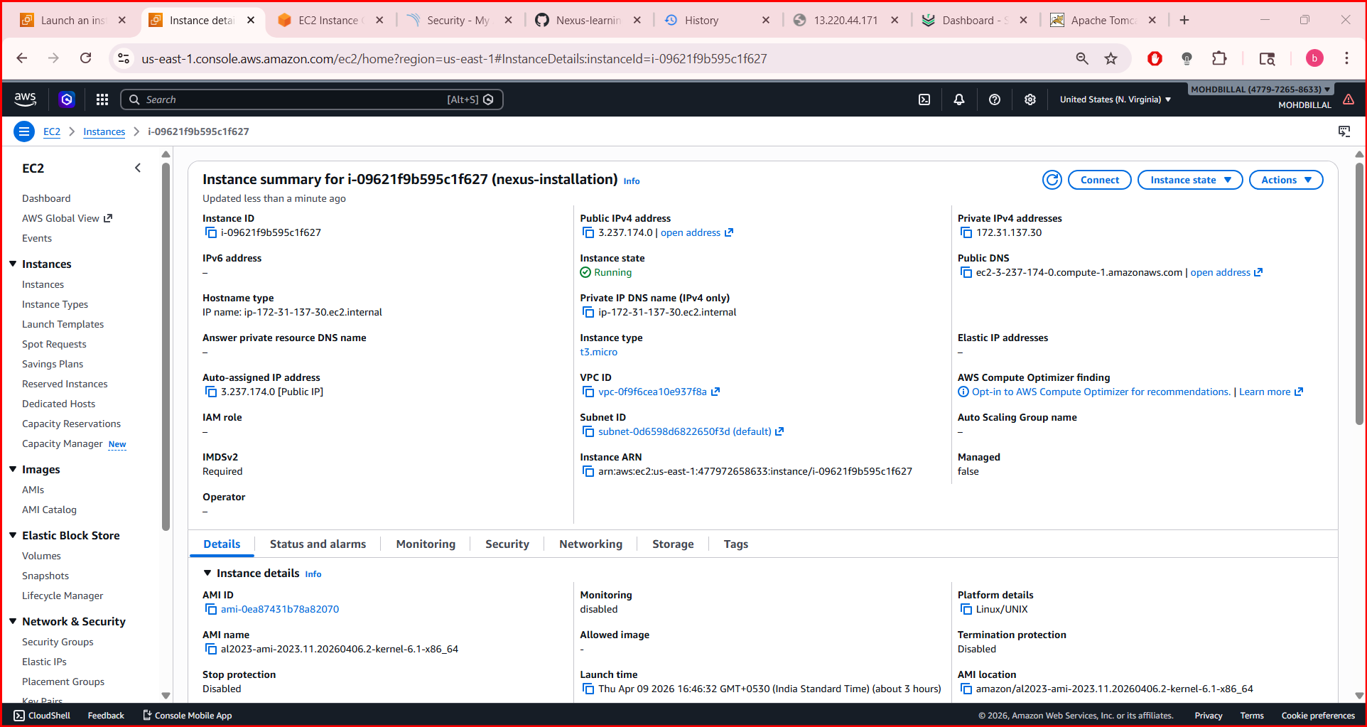
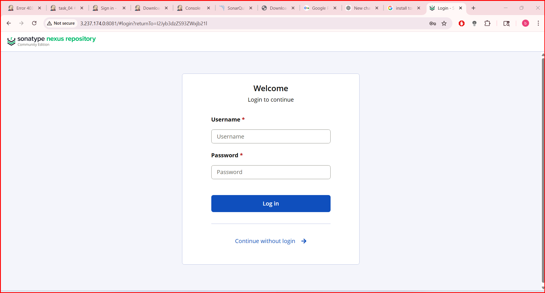

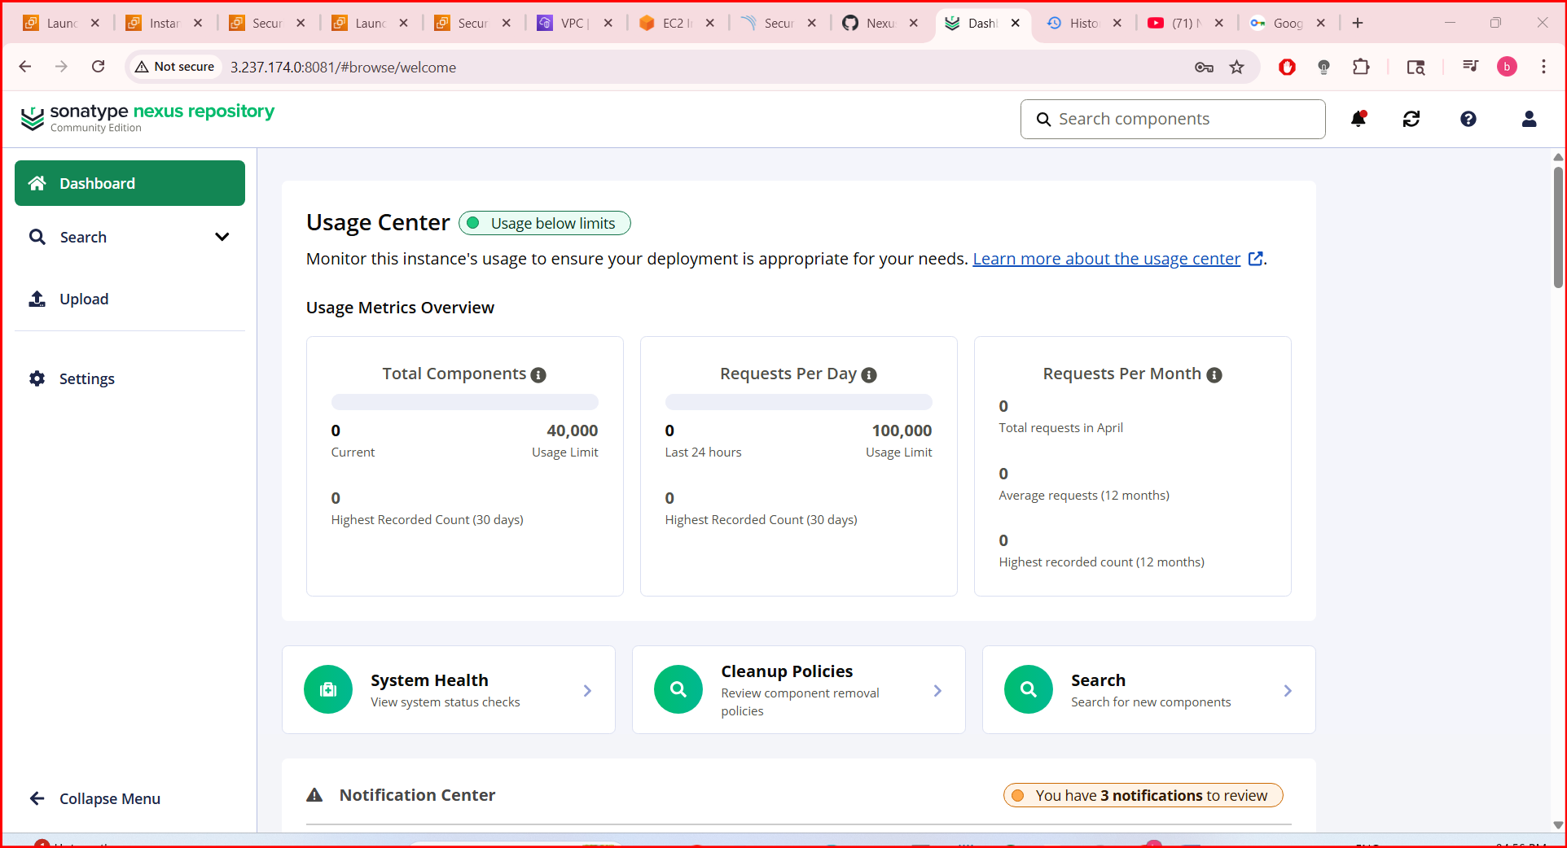

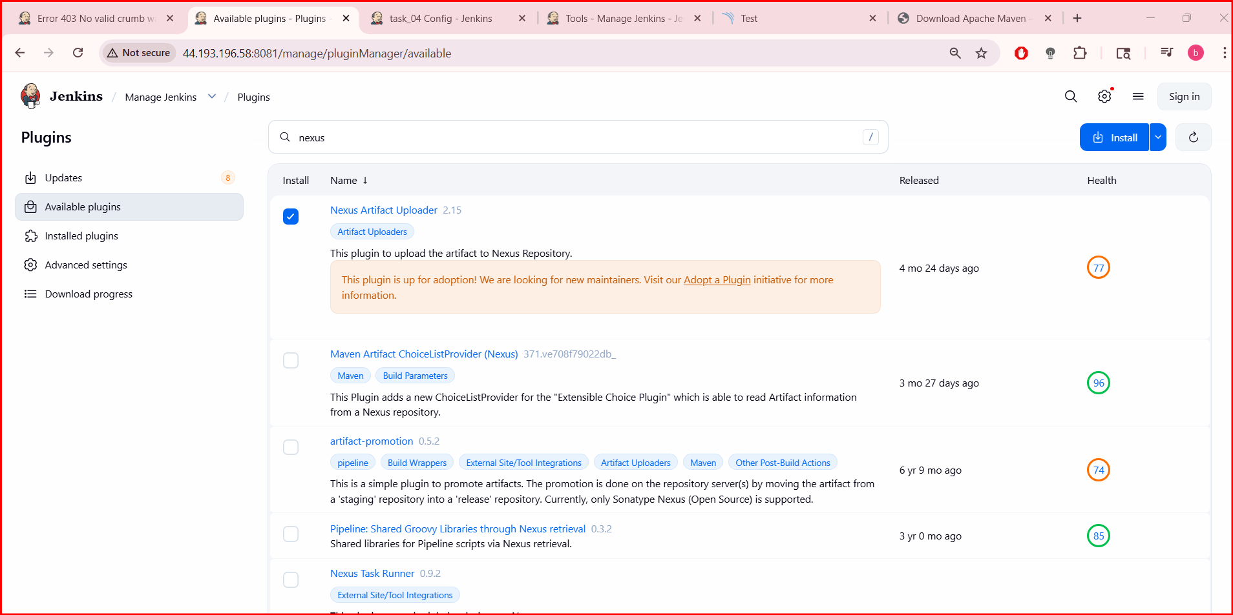
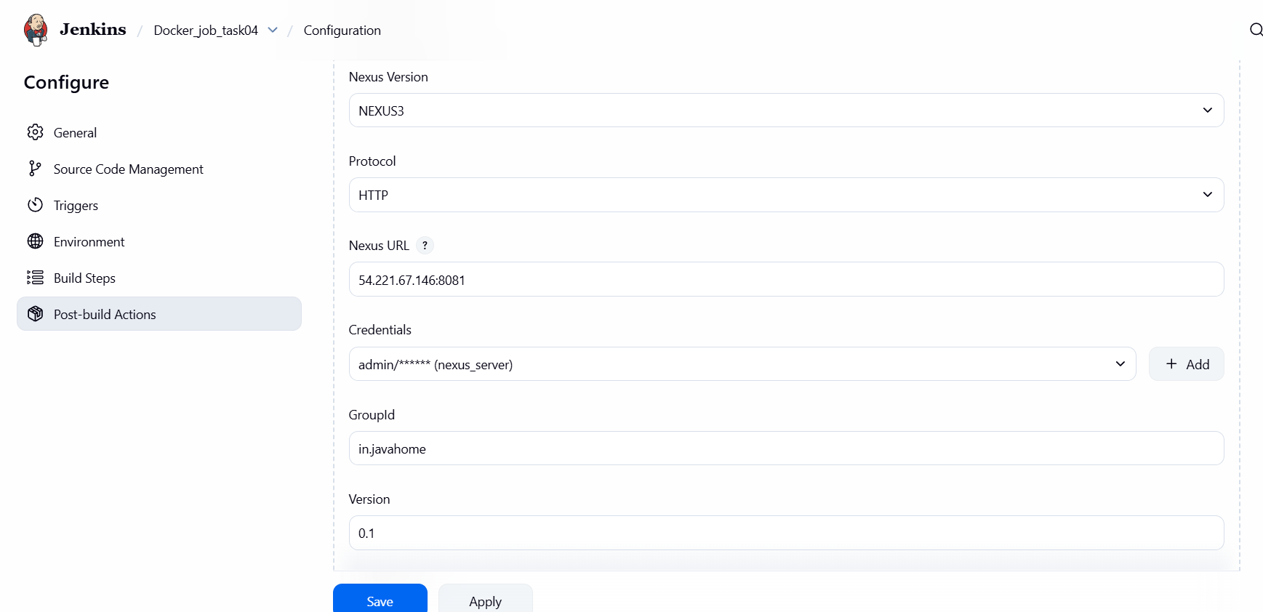
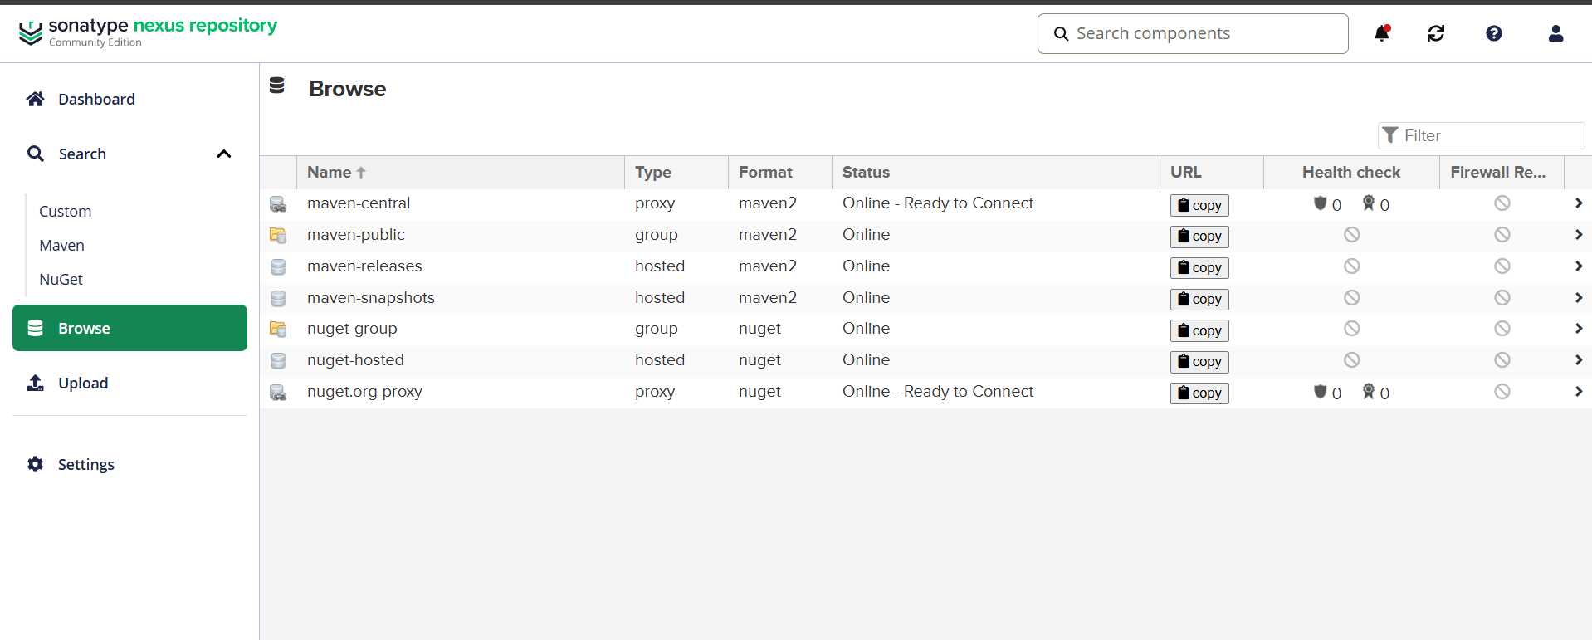
Slack Notification
Go to job select the option in slack notification and save
In my case it is configured earlier so that again integration is not required
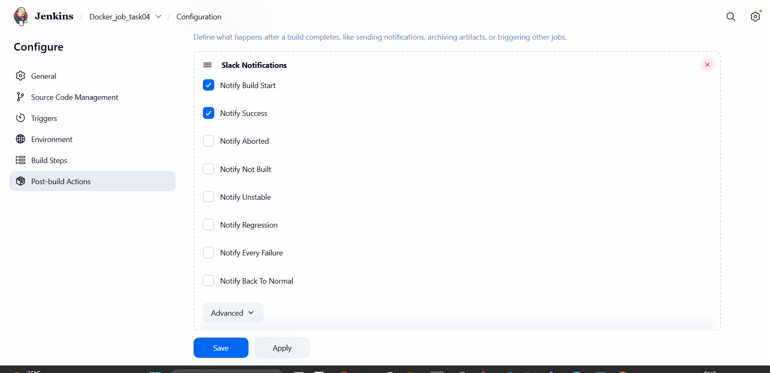
Tomcat Deployment
Launched an ec2 for installing tomcat
